Bronze Age Beaker Pottery in the Highlands
Author: Owain Scholma-Mason

The mid-third millennium BC saw the appearance and adoption of novel forms of material culture and social practices from mainland Europe. Among these new objects and practices, it is the distinctive Beaker pottery, with its sinuous or carinated profiles and often highly decorated exteriors, which has become synonymous with this period of prehistory. The overall typology of Beaker pottery in Britain is summarized by Needham (2005; 2012) and the Beaker People Project (Parker Pearson et al 2019, 173-176).

The earliest Beaker vessels in Britain date from around the 25th century BC (see Parker Pearson et al 2019, 426-428 for a recent overview of Beaker dates). In broad terms early Beakers comprise low-carinated or sinuous forms (Needham 2005; Parker Pearson et al 2019, 16–18). In Scotland these are typically decorated all over with horizontal cord impressions and show close affinities with Continental Beaker vessels. Alongside these are other examples decorated with all-over herringbone motifs, which have affinities with Dutch-style Beakers (eg at Newmill, Perthshire: Watkins and Shepherd 1978-1980), as well as examples employing comb impressed or incised motifs and undecorated vessels. During this initial ‘pioneering’ phase (Needham 2005, 41) Beakers and other novelties were relatively rare, occurring across a wide geographical area, suggestive of a diaspora-like arrival associated with small numbers of immigrants (Needham 2005, 182; Sheridan 2012c, 45). Recent aDNA analyses have identified several individuals from the Continent, highlighting the role of mobility in the initial dissemination of Beaker pottery and its associated novelties (see Parker Pearson et al 2019; Olalde et al 2018). Within Scotland this includes the young woman buried with a Low-Carinated Beaker at Sorisdale on Coll (Ritchie and Crawford 1977-1978), whose DNA profile is comparable to that of individuals buried in central Europe (Olalde et al 2018, fig 2). Despite the wide geographical spread during this ‘pioneering phase’ the overall impact of these migrants and their associated material culture and practices appears to have been relatively minor (Needham 2005; see also Sheridan 2012c).

There is a notable diversification in Beaker forms from around the 23rd century BC (Needham’s ‘fission horizon’), during which Beaker pottery and associated practices rapidly became the cultural norm, usurping earlier cultural practices (Needham 2005, 209). In Scotland, early Beakers are succeeded by ‘S’-Profile and Short-Necked Beakers. These broad groups can be further sub-divided into distinct groups as recently demonstrated for the northeast of Scotland (Curtis and Wilkin 2019). Among these distinct groups are Tall Short-Necked and Globular Short-Necked Beakers (Wilkin 2011, 27; Curtis and Wilkin 2019, Table 5.5). Short-Necked and ‘S’-Profile Beakers occur widely across Scotland and are typically associated with distinct modes of burial, which often exhibit strong gender-defined patterns (Shepherd 1989; 2012). Late Beakers in Scotland (from the 22nd century onwards) include Long-Necked and Cupped Necked examples (Curtis and Wilkin 2019).

Beaker pottery is also recorded from domestic contexts, although these sites tend to be poorly defined, comprising a handful of pits or indeterminate features, including midden spreads or coastal dune sites (Gibson 1982; 2019). Forms recorded from domestic sites overlap with those from the funerary sphere, but also include large storage jars (‘pot beakers’) as well as pots that are thicker-walled and commonly coarser than many Beakers from funerary contexts (Gibson 1982).

The following text presents a summary of the findings from the author’s doctoral research, during which the author undertook a detailed analysis of pottery from across the Highlands and Northern Isles from 2500-1800 BC (Scholma-Mason 2018; available online at https://era.ed.ac.uk/handle/1842/29647).

Beakers and Burials

Over 70 Beakers have been recorded from funerary contexts across the Highlands, often associated with a crouched inhumation set within a stone cist (Map 6.1; Datasheets 6.1; 6.4). While burials
typically comprise a single individual, examples of multiple burials are known. These typically take the form of cremated remains, although in many cases the precise nature of these deposits is unclear. At Dornoch Nursery the cremated remains of two individuals were found along with an inhumation burial (MHG40901; Ashmore 1989; see below). At Balblair, Inverness-shire, two Beakers were recorded, the smaller of which was suggested to have been made for a child, whilst the larger belonged to an adult (MHG3211; Hanley and Sheridan 1994, 138). The inclusion of multiple Beakers can extend to single inhumations, as at Findon Mains, Easter Ross (MHG8201; Galbraith 1937), and Coille Grulla, Skye (MHG4882; Scott 1929). A second vessel is recorded by Clarke at Glengolly, Caithness but the precise nature and context of this vessel is unknown (MHG2536; Clarke 1970, 516). The presence of multiple Beakers in a single burial is a well-documented phenomenon among Beaker burials; the burial of the Amesbury Archer in Wiltshire contained five Beakers (Cleal 2011, 141), whilst the burial at Upper Largie, Argyll contained three Beakers (Cook et al 2010, 75).

Only in twenty cases were Highland burials with Beakers associated with additional grave goods, typically taking the form of flint tools such as scrapers or arrowheads (Scholma-Mason 2018, 510-515). Notably among those vessels associated with other grave goods is the burial at Culduthel Mains (MHG3776), where the remains of an adult male were associated with a large Beaker, a bone belt ring, eight barbed and tanged arrowheads, an amber bead a flint scraper and a wrist guard made of Langdale tuff from Cumbria. The four perforations of the wrist guard were decorated with copper rivets with gold caps.

‘Early’ Beakers

Among the earliest examples of Beakers from funerary contexts in the Highlands are the vessels from Dornoch Nursery (MHG11738; Ashmore 1989) , Broadford, Skye (MHG55638; Birch 2012) and Battle Moss (MHG61688; Baines et al 2003; Pannett 2005; Baines and Brophy 2006). The Low-Carinated Beaker from Dornoch Nursery measured c 175mm tall with a rim diameter of c 136mm. The exterior of the vessel was decorated all over with twisted cord (AOC) impressions. The vessel was associated with the contracted skeleton of an adult male and the cremated remains of a young adult, along with a few cremated bones that may be from an infant, a stone bracer, five flint barbed and tanged arrowheads and a flint strike-a-light (Ashmore 1989, 70). A radiocarbon date of 2460-2200 cal BC was obtained for the cremated remains, placing it in Needham’s ‘pioneering phase’ (Sheridan 2007, 114). The inclusion of cremated remains with a Beaker, whilst not unusual (eg Pearson et a. 2019, 170; Clarke 1970, 453), could suggest the continuation of late Neolithic burial practices into the Chalcolithic (Scholma-Mason 2018, 321; see Gibson 2019 for a review of this topic). A residual sherd of late Neolithic Grooved Ware was also recovered from the cist fill, suggesting potential late Neolithic activity nearby (Ashmore 1989).

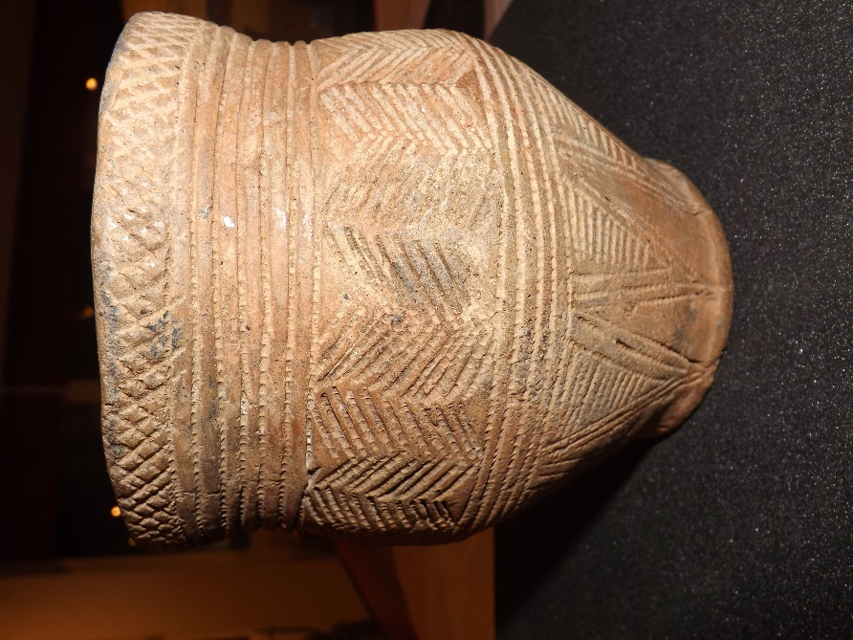
The AOC Beaker from Broadford was found set in a stone cist, sherds from a second cord-impressed vessel were recovered from the upper fills of the cist (Birch 2012). Stylistically the use of AOC decoration suggests an early date for these vessels (ibid; Needham 2005, 183) although AOC decoration on its own had a fairly long currency, lasting until the final centuries of the third millennium (Needham 2005; 2012; Sheridan 2007b). The undecorated Low-Carinated Beaker from Beechwood Park, Inverness associated with a pit grave, could be of a similarly early date. The vessel measured 120mm tall with a rim diameter of 115-119mm. Analysis of the Beaker suggests that the walls had been thinned using a spatula, a technique seen on the Continent, suggesting that new modes of pottery production were introduced alongside Beakers (MHG48626; Suddaby and Sheridan 2006).

At the Battle Moss ring cairn, sherds from at least three Beakers were found adjacent to a large upright slab which could have formed one side of a putative cist, which was subsequently damaged during re-modelling of the ring cairn (Baines et al 2003). Among the Beakers was a large example measuring c 202mm tall with an estimated rim diameter of c 150mm. The exterior is decorated with five sets of herringbone decoration created by jabbing a narrow tool diagonally into the clay (A. Sheridan pers comm). This mode of decoration as noted previously finds clear parallel among European Beakers, including those from the Netherlands (ibid). The association of Beaker pottery with ring cairns is well documented, largely due to Richard Bradley’s work on the Clava Cairns near Inverness (Bradley 2000) and recumbent stone circles in northeast Scotland (Bradley 2005).
Figure 1: Decorated Beaker from Dalmore, Ross & Cromarty (© Owain Scholma-Mason)

‘Later’ beakers

The bulk of the radiocarbon-dated Beakers in the Highlands fall around or after the early 23rd century BC, after Needham’s ‘fission horizon’ (Scholma-Mason 2018, 463); see also Datasheets 6.1 and 6.4). The relationship between these ‘later’ Beakers and the ‘early’ Low-Carinated/ AOC vessels is at present unclear, due in part to a lack of chronological resolution and the low number of early Beaker finds (Healy 2012; Sheridan 2012c, 50-51). This is especially notable in the Highlands where the number of radiocarbon-dated Beakers from funerary contexts is relatively small (Chapter 6, Table 6.5). While it is tempting to see a direct evolutionary line from early to later Beaker forms, the evidence for overlap and continuity is limited, and further dating is needed to understand the development of Beaker pottery within the region.

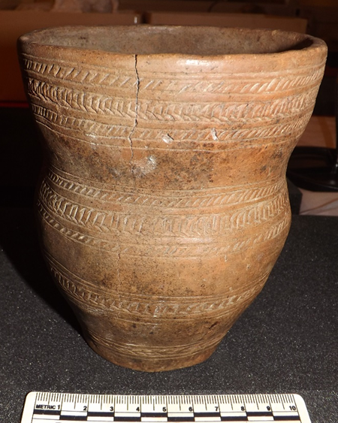
Short-Necked Beakers in the Highlands range from 84–228mm tall with rim diameters ranging from 84-157mm. Amongst these are the example from Chealamy, Sutherland, associated with an adult male inhumation (MHG9580; Gourlay 1985). The larger of the two Beakers from Balblair was decorated with fine-toothed comb impressions, whilst the smaller Beaker was decorated by incision organised into three zones (MHG3211; Hanley and Sheridan 1994, 135-136). The Short-Necked Beaker from Fyrish, Easter Ross (MHG8104) was associated with a stone bracer. The associated remains were dated to 2345-2145 cal BC (Chapter 6, Table 6.5; Sheridan et al 2019). The style of decoration on the Fyrish Beaker is highly ornate: the neck is decorated by a set of incised panels and a band of infilled hexagons just below the waist. A further highly decorated example is attributed to a cemetery at Dalmore, Ross and Cromarty (MHG6311, Jolly 1879; see Scholma-Mason 2018, 390, Table 9.5 for a review of these finds) (Fig 1). The vessel from the cist at Acharole, Caithness (MHG1980), was decorated using comb impressions. The motifs, divided into five zones, are comparable to the Beaker from Glengolly (MHG2536). Found with an adult male, placed on his right-hand side, the Acharole Beaker was probably placed behind the head (Scholma-Mason 2018, 324, 692). The burial at Acharole is about 9.5km to the northeast of the burial at Achavanich (MHG13613) with its ‘S’-Profile Beaker (Hoole et al 2017).
Figure 2 Beaker from Lochend, Inverness-shire (© Owain Scholma-Mason)

In contrast to Short-Necked forms, ‘S’-Profile Beakers have sinuous profiles, with little distinction between the neck and body of the vessel. In general, they are typically taller than Short-Necked vessels, ranging from 120-205mm in height). Rim diameters range from 98-140mm (Scholma-Mason 2018, 469). Vessels are typically decorated with comb impressions or incisions or a combination of incision and comb decoration. The Beaker from the Mains of Balnagowan employed a combination of comb impressions and incisions, although the latter was restricted to two lines (Shepherd et al 1985, 565). Where osteological data are available these are associated with both male and female inhumations. Among the latter is the example from Achavanich, which has recently been subjected to detailed re-appraisal, including new radiocarbon dates and DNA analysis (Hoole et al 2017; see also Case study Ava Bronze Age burial). Based on its associations, the burial with an ‘S’-Profile Beaker from Dunrobin Park, Sutherland could belong to a young female. Along with the Beaker, eighteen quartz pebbles and 118 shale disc beads (of which only six were perforated) were recorded (MGH39731; Joass 1904, 61). The undecorated ‘S’-Profile Beaker from West Torbreck, Inverness-shire was associated with a female burial and radiocarbon dated to 1982-1889 cal BC (MHG56812; Kilpatrick 2014). Other examples of ‘S’-Profile Beakers include the vessels from Holm Mains Farm, Inverness (MHG32415) dated to 2290-2030 cal BC and 2280-2030 cal BC (Chapter 6, Table 6.5; Sheridan 2006).

‘S’-Profile forms are common north of the Great Glen, whilst Short-Necked vessels appear to be common south of Sutherland, although the available sample is quite small. Further discoveries will aid in further exploring potential regional differences across the Highlands. In Sutherland further differences with Inverness to the south can be detected in the general preference for Food Vessels, concentrated along the Golspie coast, and the general absence of late Cupped- or Long-Necked Beaker forms, recorded to the south. Cupped- or Long-Necked Beakers are typically dated to around the start of the 22nd century BC (Curtis & Wilkin 2019, 226). The differences in preferred vessel forms in Inverness and Sutherland probably reflect regional preferences across the Highlands for certain vessel forms, which also extends to variations in burial setting, positioning and associated grave goods (Scholma-Mason 2018; Curtis & Wilkin 2019).

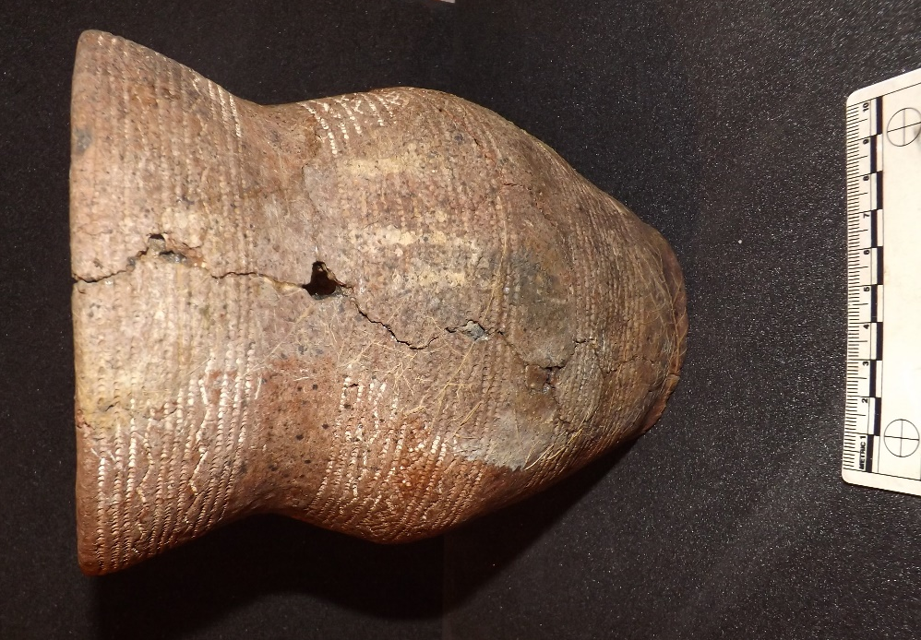
Among the latest recorded Beakers from the Highlands is the Cupped-Necked vessel from Lochend, Inverness-shire (Childe et al 1943-1944) (Fig 2) dated to 1950–1750 cal BC (Sheridan 2007b), overlapping with the date from West Torbreck. The form of the vessel is similar to the Beaker recorded from a cist at Drumashie, Inverness-shire (MHG3542), with its wide flaring neck (Fig 3). Other examples include the cupped-necked vessel from Poolewe (MHG7709) and the highly decorated vessel from Cnocan Na Cobhar, Inverness-shire (MHG41552). Alongside these vessels are examples of Long-Necked Beakers, including the example from Seafield West, Inverness-shire
Figure 3 Beaker from Drumashie, Inverness-shire (© Owain Scholma-Mason)
(MHG3944, Cressey & Sheridan 2003). The Seafield West vessel was associated with a short cist which formed part of a wider cemetery complex.

Chambered Cairns and other monuments

Beaker pottery is recorded from around nine chambered cairns in the Highlands. This includes the majority of Low-Carinated examples (Scholma-Mason 2018, 456; see also Wilkin 2016 for a discussion of the deposition of Beakers in Neolithic chambered cairns). Beaker vessels and or sherds are often found as either stray finds or as part of secondary burials set into the chamber or mound, as at the recent example from the Neolithic Clyde cairn at Cladh Aindreis on the Ardnamurchan peninsula (MHG459; Harris et al 2010). At the Orkney-Cromarty type chambered cairn at Cnoc Na H’Uiseig, Caithness, sherds of two or three Beakers were recorded from inside the irregularly shaped inner chamber (MHG2479; Edwards 1928, 141). The remains of a further Beaker were recorded in a secondary cist inserted into the chamber following the collapse of the roof (Davidson and Henshall 1991, 126). The Beakers were highly fragmentary but comprised sherds of sinuous or Low-Carinated vessels decorated with bands of twisted cord.

Several Beakers and Food Vessels were recorded from the Orkney-Cromarty type chambered cairn at Embo (MHG45275; Henshall and Wallace 1965). The Beakers included Low-Carinated or ‘S’-Profile types decorated with comb impressions. Among the assemblage was a vessel that exhibits Beaker and Food Vessel traits (Henshall and Ritchie 1995, Fig 23) and is similar to the vessel from Loch More (MHG12959; Proc Soc Antiq Scot 1968-1969, 293). The other Beakers from Embo include sinuous or Low-Carinated types decorated with twisted cord.

At Kilcoy South, Ross and Cromarty, multiple sherds of Low-Carinated vessels were found intermixed in the infilling of the chamber and are based on their typology likely to have been deposited in two stages (MHG9017; Henshall and Ritchie 2001, 71). At least six vessels are represented including three Low-Carinated Beakers decorated with all over cord or comb decoration. The size and decoration of these recall the large vessels recently excavated at Culduthel Farm (see below). Alongside these the remains of a Short-Necked Beaker decorated by incision suggests a later phase of Beaker deposition.

Beakers and Domestic Contexts
Beaker pottery has also been recorded at several putative domestic sites (Scholma-Mason 2018), including at Cul na Croise and Sanna Bay Lochaber (MHG13230, MHG14370; for an overview of these see Ritchie 1973, Scholma-Mason 2018, 375), Home Farm, Portree (Kiltaraglen), Skye (MHG51648; Suddaby 2013), Freswick Sands, Caithness (MHG1669; Gibson, 1982, 158), Fortrose and Rosemarkie Waste Water Works (MHG60875; Sheridan 2014) and Culduthel (MHG56078; Murray 2008 and MHG49950; Hatherley and Murray forthcoming 2021). In contrast to funerary examples, Beakers from domestic sites across Britain are often poorly preserved and, in many cases, are from poorly stratified contexts (see Gibson 1982 for a review).

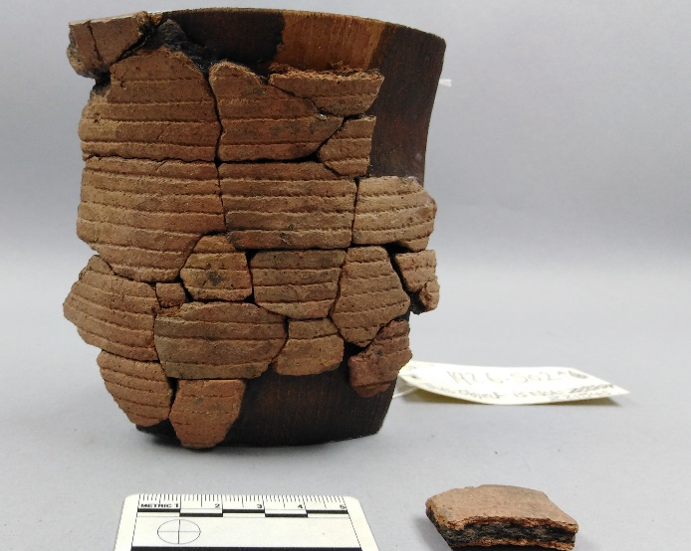
The sherds of Beaker pottery recorded at the coastal dune sites of Freswick Sands, Caithness and Cul na Croise and Sanna Bay, Lochaber were not recorded in association with any domestic structures, and the interpretation of these site is problematic. Examples of Beaker pottery are widely recorded from coastal dune sites (as listed by Gibson 1982; 2019, 323), which have most recently been interpreted as meeting or gathering points (Bradley et al 2016). AOC decorated sherds have been recorded from Sanna Bay, including a probable Low-Carinated/ ‘S’-Profile vessel (Fig 4), and is suggestive of an early date for activity at the site. The assemblage from Freswick Sands, comprised of an array of material that has been collected since the early 20th century, was more mixed and included sherds of Grooved Ware, hinting at multiple phases of use throughout the 3rd millennium BC (Gibson 1982, 158).

Excavations at Lairg, Sutherland, recorded Beakers and Food Vessels in funerary contexts, but also small, weathered sherds from tilled soils under Burial Cairn 1 and from under House 6 (McCullagh and Tipping 1998). During excavations at Kilearnan Hill, Helmsdale, Sutherland, a few small fragments of Beaker pottery were recovered from early soil contexts (MHG9986, McIntyre 1998). Ephemeral structural remains were recorded at Rosskeen East during commercial excavations (MHG17488; Wordsworth 1993). The date of the structure is uncertain but is likely to be Bronze Age or later. Multiple pottery sherds were recovered from the structure and included examples decorated by incision and twisted cord, possibly from Beakers (Scholma-Mason 2018, 380-1).
Figure 4 Beaker from Sanna Bay (© Susan Kruse)

During excavations at Culduthel Mains Farm (Phases 7 & 8) a range of Beaker and various coarse sherds were recovered. The Beaker assemblage numbers around 23 pots and includes large Low-Carinated Beakers (MHG56078); Murray 2008; Hatherley forthcoming). Similar Low-Carinated or ‘S’-Profile AOC decorated vessels were recorded from Rosemarkie, Easter Ross, where 19 Beakers were recovered from pits (MHG60791; Fraser 2014). At Home Farm, Portree (Kiltaraglen), Skye, 114 sherds of Beakers (c. 40 vessels) were recovered from two pits, which formed part of a wider series of pits forming a probable curving alignment (MHG51648; Suddaby 2013). Where vessel forms were definable, they typically took the form of narrow mouthed/ closed jars, similar to vessels from Northton, Western Isles (Suddaby 2013; Scholma-Mason 2018, 377).

Discussion

This summary has only touched on a select number of Beaker finds from the Highlands, illustrating their characteristics and patterns of association. Within the Highlands we can detect key focal points, although in some cases these concentrations of material are in part due to more intensive episodes of fieldwork, especially around Inverness, where large numbers of funerary and probable domestic sites have been recorded in association with Beaker pottery. This concentration is probably due to its position at the northeastern end of the Great Glen, which formed a key arterial routeway to Ireland (Curtis and Wilkin 2012, 246). This connection is further emphasized by the presence of later Irish style Food Vessel pottery from Seafield West (Cressey and Sheridan 2003), Irish style decoration on Beakers in northeast Scotland (Curtis and Wilkin 2019, 230) and isotopic evidence, notably the adult male buried at Culduthel (MHG3776; Montgomery et al 2019, 395).

The presence of early Beakers within the regions aids in our understanding of the extent of the early phase of Beaker use. In the Highlands this includes a focus and or interest in early monuments where quantities of early Beakers have been recorded, including the assemblage from Kilcoy South chambered cairn. Whilst vessel forms and modes of deposition find parallels across Britain there are notable regional differences. Regional preferences for forms can be detected with a bias towards ‘S’-Profile forms in Sutherland, which appear to be associated with female burials, although the available osteological data is limited. Future research into old finds, as shown by the recent Beaker People Project (Parker Pearson et al 2019), and specifically in the context of the Highlands, the Achavanich project (Hoole et al 2017), will be of aid in further refining this picture. As shown clearly by the Achavanich project there is much potential in revisiting older assemblages to develop a more nuanced understanding of the individuals associated with Beaker vessels, and in turn the significance of Beaker vessels.

Acknowledgements
Many thanks to Alison Sheridan who provided invaluable comments on an early draft of this article, and thanks also to Susan Kruse for her support and patience in getting this work completed.

